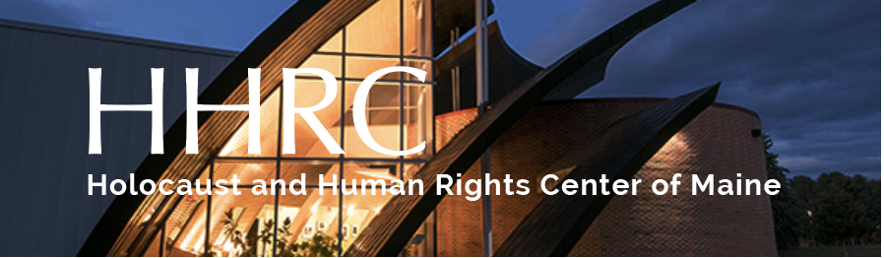

Mathilde Schlossberger
Outstanding Student of the Year Award

The Schlossberger Award was created by Florence and Kurt Strauss or Portland in memory of Kurt’s maternal grandmother, who was murdered at Theresienstadt.

The award recognizes students at three grade levels (K-4, 5-8, 9-12) who have produced an exceptional piece of original writing, fiction or non-fiction, or an unusually expressive piece of visual or performance art relating to human rights.

ART

Projects may be visual art (painting, drawing, etc) or mixed media (sculpture, Power Point, etc). For grades 5- 12, category also includes performance. Criteria: originality, expressiveness, artistic skill, communication of meaning or message.

WRITING

Projects may be poetry, short story, essay, or personal reflection. Length: four page limit.
For grades 5 – 12, category also includes drama.

Criteria: originality of voice and viewpoint, structure, command of language and mechanics.

REQUIREMENTS

Art, writing, video, or photographs of art must be delivered to HHRC, along with a completed nomination form, by April 15, 2024.

Submissions, along with a completed application form may be delivered in person, emailed, or mailed to:

Holocaust & Human Rights Center of Maine
Michael Klahr Center, UMA
46 University Drive
Augusta, Maine 04330
207.621.3530
infohhrc@maine.edu

In the event that works of visual art are honored, we ask that the art be made available for display at our annual meeting. All winners will be recognized and asked to speak about their work at our annual meeting.

Application Form:

I think I’ve found the recipient of the Outstanding Student of the Year Award.

His/her/their name is __________________________________________________ Grade ___________

Address _____________________________________________________________________________

City, State, Zip ___________________________________________ Phone _____________________

Nominated by ____________________________________________ Position _____________________

School Name ________________________________________________________________________

School Address _______________________________________________________________________

____________________________________________________________________________________

Phone __________________________________ Email _____________________________________

Briefly describe what your nominee has written or created, the title of the piece, and how this work meets the Schlossberger Award criteria. Attach photos for all artwork.

Use additional paper, if necessary.

